STANDARD FORM
Pearson Edexcel - Thursday 6 June 2019 - Paper 2 (Calculator) Higher Tier
1.
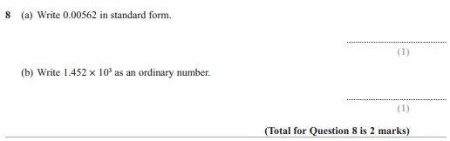
Pearson Edexcel - Thursday 8 November 2018 - Paper 2 (Calculator) Higher Tier
2.
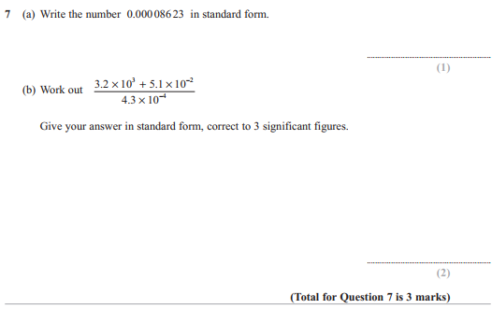

Pearson Edexcel - Specimen Papers Set 1 - Paper 3 (Calculator) Higher Tier
3.
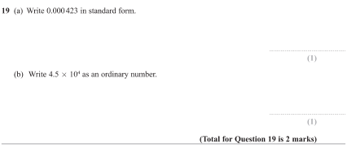
4.
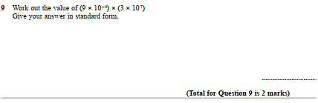
Pearson Edexcel - Sample Paper 3 - (Calculator) Higher Tier
5.
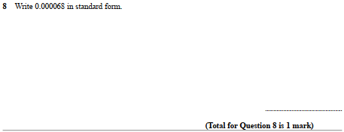

Pearson Edexcel - Friday 6 November 2015 - Paper 2 (Calculator) Higher Tier
6.
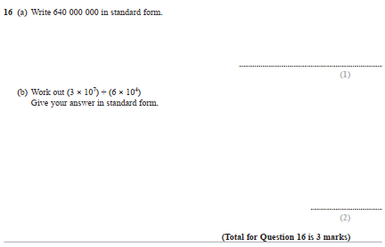
Pearson Edexcel - Monday 8 June 2015 - Paper 2 (Calculator) Higher Tier
7.
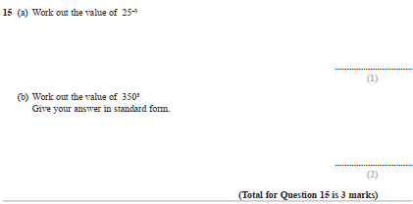

Pearson Edexcel - Friday 13 June 2014 - Paper 2 (Calculator) Higher Tier
8.
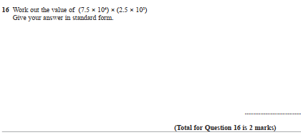

Pearson Edexcel - Wednesday 6 November 2013 - Paper 1 (Non-Calculator) Higher Tier
9.
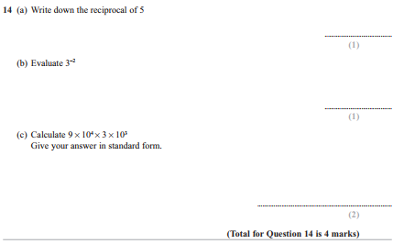

Pearson Edexcel - Friday 8 November 2013 - Paper 2 (Calculator) Higher Tier
10.
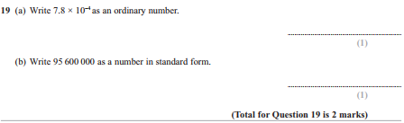

Pearson Edexcel - Thursday 28 February 2013 - Paper 1 (Non-Calculator) Higher Tier
11.
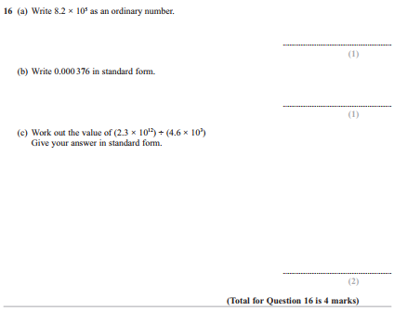

Pearson Edexcel - Friday 2 March 2012 - Paper 3 (Non-Calculator) Higher Tier
12.
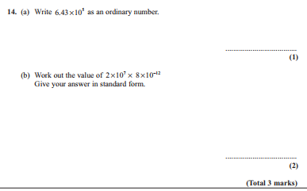

Pearson Edexcel - Wednesday 9 November 2011 - Paper 3 (Non-Calculator) Higher Tier
13.
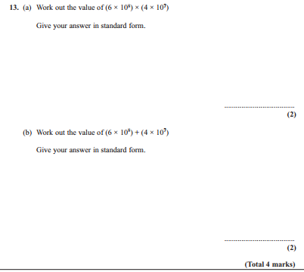

Pearson Edexcel - Friday 10 June 2011 - Paper 4 (Calculator) Higher Tier
14.
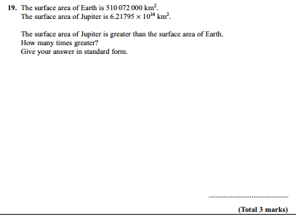
Pearson Edexcel - Friday 12 November 2010 - Paper 4 (Calculator) Higher Tier
15.
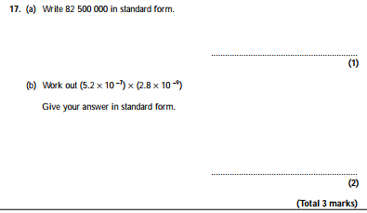

Pearson Edexcel - Friday 11 June 2010 - Paper 4 (Calculator) Higher Tier
16.
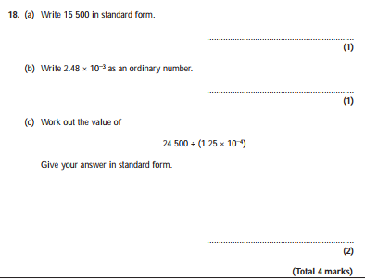

Pearson Edexcel - Thursday 5 November 2009 - Paper 3 (Non-Calculator) Higher Tier
17.
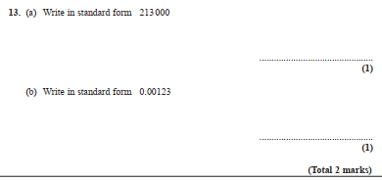
OCR GSCE – Tuesday 3 November 2020 – Paper 4 (Calculator) Higher Tier
18.
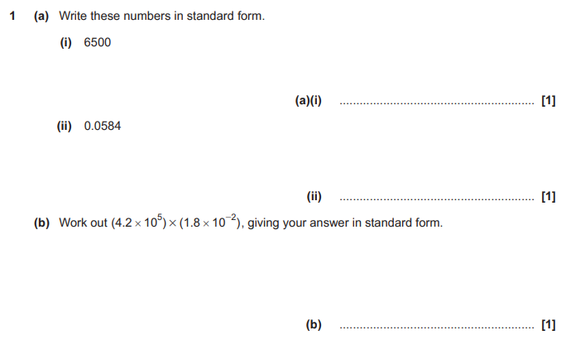

OCR GSCE – Tuesday 5 November 2019 – Paper 4 (Calculator) Higher Tier
19.
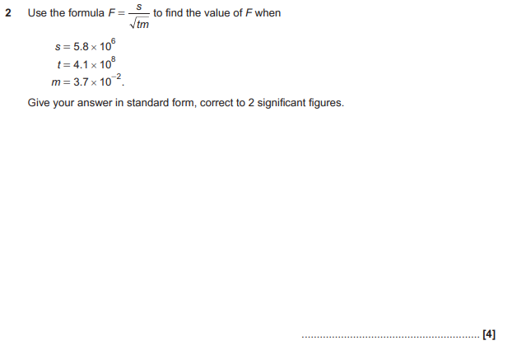

OCR GSCE – Thursday 6 June 2019 – Paper 5 (Non-Calculator) Higher Tier
20.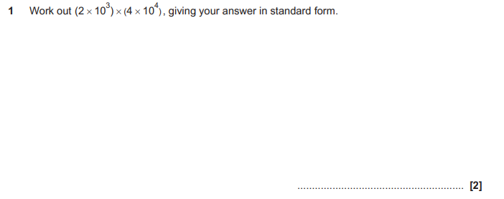
OCR GSCE – Tuesday 11 June 2019 – Paper 6 (Calculator) Higher Tier
21.
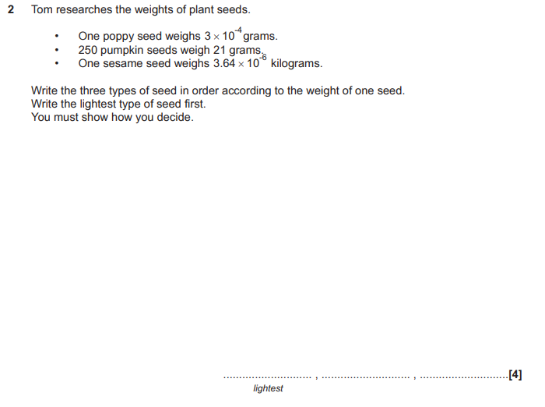

OCR GSCE – Thursday 8 November 2018 – Paper 5 (Non-Calculator) Higher Tier
22.
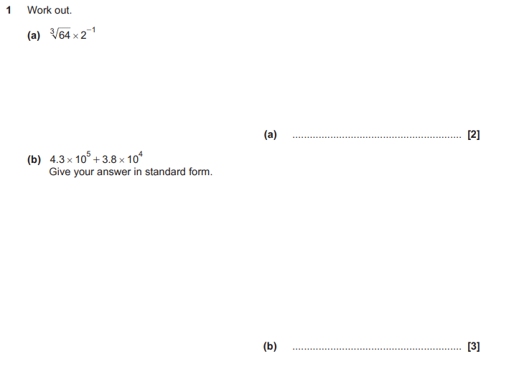

OCR GSCE – Monday 12 November 2018 – Paper 6 (Calculator) Higher Tier
23.
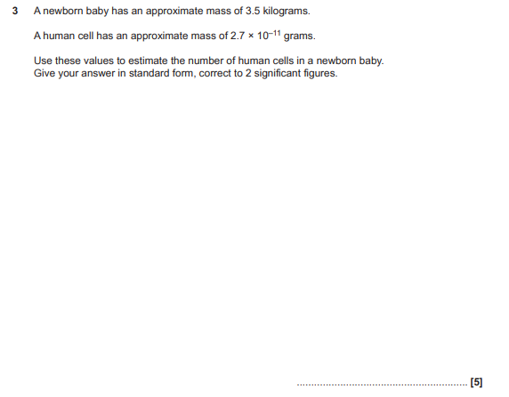

OCR GSCE – Thursday 7 June 2018 – Paper 5 (Non - Calculator) Higher Tier
24.
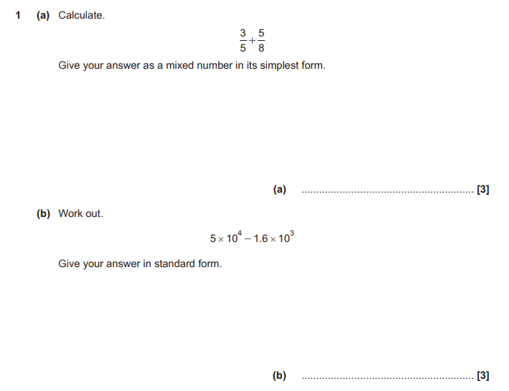

OCR GSCE – Wednesday 8 November 2017 – Paper 6 (Calculator) Higher Tier
25.
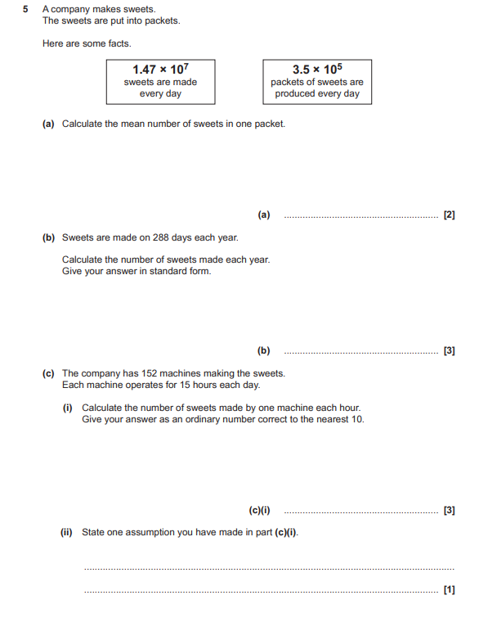

OCR GSCE – Tuesday 13 June 2017 – Paper 6 (Calculator) Higher Tier
26.
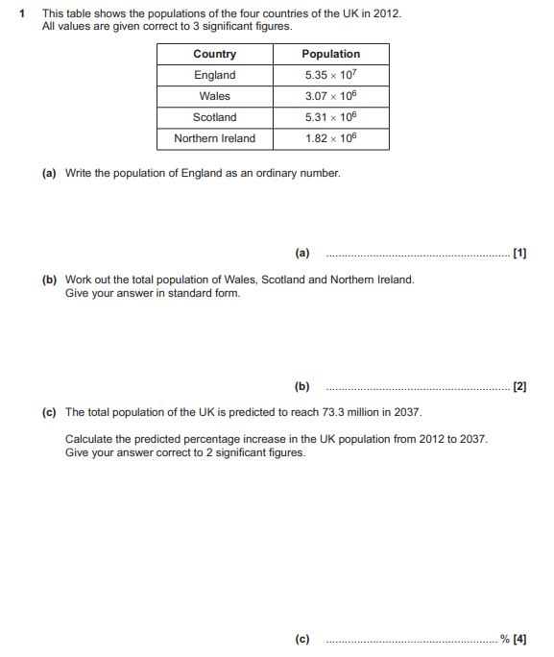

AQA GSCE – Thursday 4 June 2020 – Paper 2 (Calculator) Higher Tier
27.
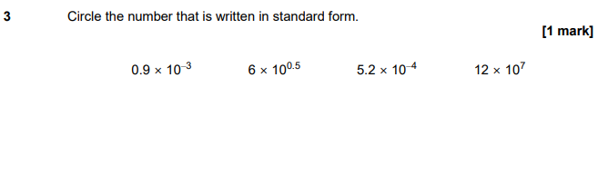
AQA GSCE – Tuesday 21 May 2019 – Paper 1 (Non - Calculator) Higher Tier
28.
AQA GSCE – Tuesday 21 May 2019 – Paper 1 (Non - Calculator) Higher Tier
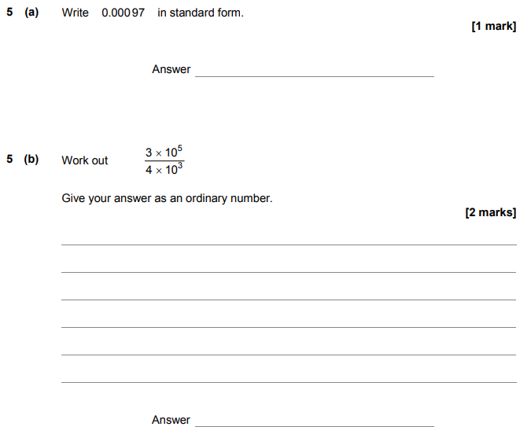
AQA GSCE – Thursday 8 November 2018 – Paper 2 (Calculator) Higher Tier
29.
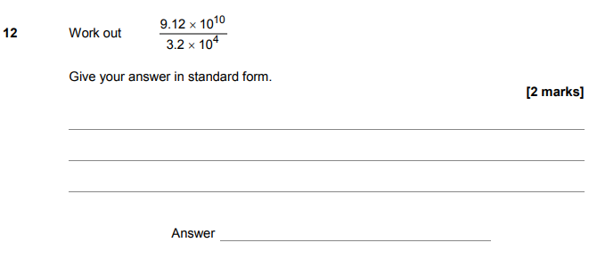
AQA GSCE – Thursday 7 June 2018 – Paper 2 (Calculator) Higher Tier
30.
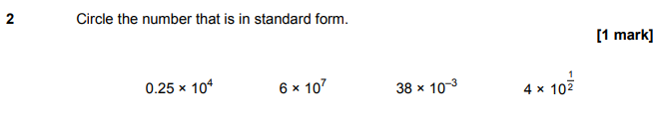
AQA GSCE – Thursday 2 November 2017 – Paper 1 (Non - Calculator) Higher Tier
31.
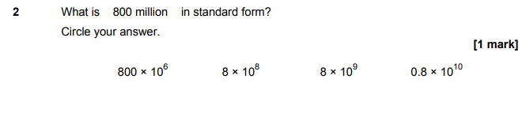

AQA GSCE – Wednesday 25 May 2017 – Paper 1 (Non - Calculator) Higher Tier
32.
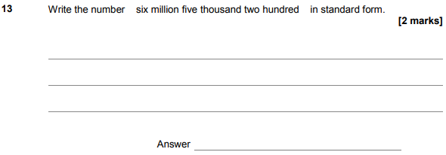
AQA GSCE – Thursday 8 June 2017 – Paper 2 (Calculator) Higher Tier
33.
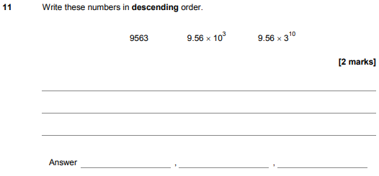
AQA GSCE – Sample Paper 1 (Non - Calculator) Higher Tier
34.
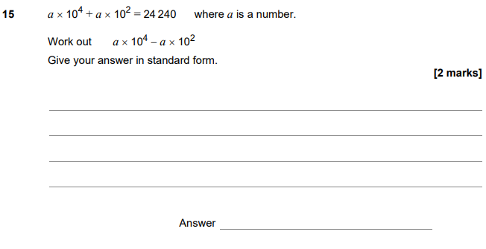
AQA GSCE – Sample Paper 2 (Calculator) Higher Tier
35.
